Master Blueprint: 4-DOF Wireless Gesture-Controlled Robot Arm

Phase 1: The High-Level Overview (Big Picture)
The data flows like a river through the system:
$Motion \left(Hand\right)→ Transmitter \left(ESP32\right)→\left\{Wireless\right\}→ Receiver \left(ESP32\right)→\left\{Wired\right\} → Controller (TM4C) → Action (Servos)$
Phase 2: The Transmitter (The Glove/Remote)
This unit reads your hand movements and creates the data packet.
Parts:
- ESP32 NodeMCU: The Brain.
- MPU9250: Accelerometer + Gyroscope (Communicates via I2C).¹
- Power: 2x 18650 Li-ion Batteries (7.4V) connected to the VIN pin.
- Button: BOOT Button (GPIO 0) used for Claw control.
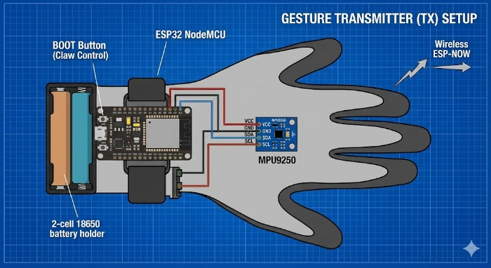
Connections:
- MPU VCC $→$ ESP 3.3V
- MPU GND → ESP GND
- MPU SDA $→$ GPIO 21
- MPU SCL $→$ GPIO 22
Software Logic (Loop Flow):
- Read Sensors: Acquire raw Accelerometer and Gyroscope data from the MPU9250.
- Process (Madgwick): Feed the raw data into the Madgwick filter algorithm $→$ Output Roll, Pitch, and Yaw (Float values).
- Map: Convert the Float angles (e.g., -90 to +90 degrees) into the Servo Range (0 to 180) using the map() function.
- Check Claw:
  - If BOOT button is pressed → Set Claw = 180 (Close).
  - Else $→$ Set Claw = 0 (Open).
- Pack: Stuff the mapped data into a struct (Total size: 4 Bytes).
- Send: Fire the data wirelessly using esp_now_send()!

Phase 3: The Receiver Bridge (The Postman)
Its job is strictly that of a postman. Take the packet and pass it forward.
Parts:
- ESP32 NodeMCU: Acts only as a WiFi receiver.
- Power: Powered via the a shared battery rail.
Connections (Crucial Step):
- ESP32 Tx2 (GPIO 17) $→$ TM4C Rx1 (PB0).
- ESP32 GND $→$ TM4C GND (Common Ground is mandatory!).
Software Logic:
- Listen: The OnDataRecv() callback function waits for incoming data.
- Receive: As soon as a packet arrives, copy it into the local struct.
- Re-Package: Create an "Envelope" or Frame for the TM4C:
  - Header (0xFF)
  - Base Byte
  - Shoulder Byte
  - Elbow Byte
  - Claw Byte
  - Footer (0xFE)
- Forward: Send the frame using Serial2.write().

Phase 4: The Robot Controller (The Muscle Brain)
The real hard work happens here: Data parsing and Motor synchronization.
Parts:
- Tiva C (TM4C123GH6PM): Main Controller.
- 4x Servo Motors: (Base, Shoulder, Elbow, Claw).
- Power: 3x 18650 Batteries (11.1V).
- Voltage Regulator: XL4015 Buck Converter (Step down 11.1V to 6V).
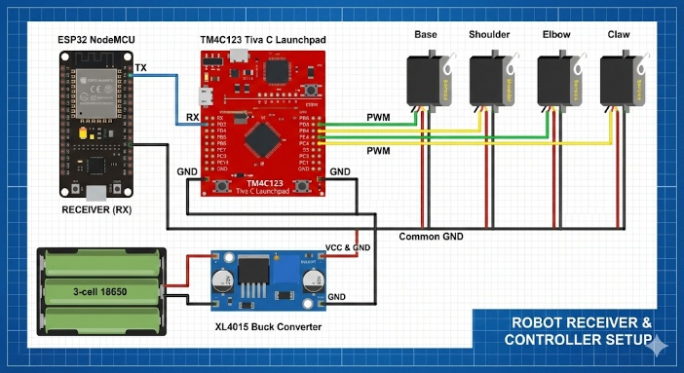
Connections:
- UART: PB0 (Rx1) receiving data from the ESP32.
- PWM Pins:
  - Base $→$ PB6 (M0PWM0)
  - Shoulder $→$ PB4 (M0PWM2)
  - Elbow $→$ PE4 (M0PWM4)
  - Claw $→$ PC4 (M0PWM6) (Note: Check PinMux; if PC4 is tricky/locked, use another Generator).
Power Wiring :
- Batteries $→$ XL4015 Input.
- XL4015 Output (Set to 6V) $→$ Servo VCC pins (Red wires).
- Servo GND (Brown wires) $→$ XL4015 Output GND AND TM4C GND.
- Servo Signal (Orange wires) $→$ TM4C PWM Pins.
Software Logic:
- Init: Setup UART (115200 baud) + Setup PWM (50Hz frequency, Sync enabled).
- UART Interrupt: When data arrives, perform checks:
  - "Is the first byte 0xFF?" $→$ Yes.
  - "Store the next 4 bytes."
  - "Is the last byte 0xFE?" $→$ Yes.
- Action: If the packet is valid:
  - Convert received values (0-180) into PWM Duty Cycle (High Time counts).
  - Formula: Duty = (Angle * Scaling) + Min_Pulse.
  - Update CMPA registers.
  - Trigger PWM_SYNC so all motors move simultaneously.

Phase 5: The Part Flow (Bill of Materials)
Electronics:
- 2x ESP32 NodeMCU.
- 1x MPU9250 Module.
- 1x TM4C123 Tiva C Launchpad.
- 4x Servo Motors (Use MG996R for Base/Shoulder, SG90 for Claw).
- 1x XL4015 Buck Converter Module.
Power:
- 5x 18650 Li-ion Cells (2 for Tx, 3 for Rx).
- Battery Holders (2-slot and 3-slot).
- Jumper Wires (Female-Female, Male-Female).
Mechanical:
- 3D Printed Robot Arm parts (or Acrylic kit).

Final Checklist for "MPS Wale Bhai" Setup:
- Calibrate First: Place the MPU9250 flat on a table and calibrate it (using the 'c' command feature in your code) before use.
- Buck Converter Tuning: Connect the XL4015 to the battery and turn the screw to set the output voltage to 6V before connecting the Servos. Otherwise, the servos will go "Kaboom".
- Common Ground: I cannot stress this enough—The ESP32, TM4C, and Buck Converter grounds must all be connected together.

